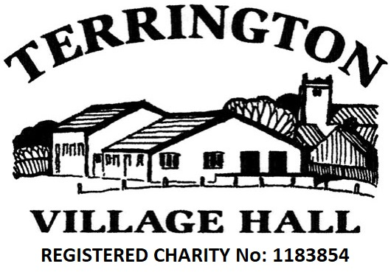
Terrington Village Hall & Recreation Ground
Reg. Charity No. 1183854
Booking Agreement Form
Data Privacy: The personal info in this form will only be used for processing your booking & invoicing for payment. It will be retained for no more than 7 years. We will not share the data with any 3rd parties.
SECTION 1: DETAILS OF THE HIRE (to be completed by the Hirer)
Purpose Of Hiring |  |  |  |  |  |  |  |  |  |  |  |  |  |  |  |  |  |  |  |  |  | Expected No. of Attendees
Organisation (if applicable)
Hirer Contact Name
Hirer Contact Address
Hirer Contact Tel. No. |  |  |  |  |  |  |  |  |  |  |  |  |  | Email
Nominated Responsible Person (see §1 of Conditions of Hire)
Minimum booking is 1 hour. A 15 minutes allowance for set up and set down time is assumed either side of your booking.
If you need more set up / set down time than this then please book additional half-hours as required.
Date(s) |  |  |  |  |  |  |  |  | Start & End Times |  |  |  |  |  |  |  | Frequency of Booking (One Off, Weekly, etc.)
VILLAGE HALL FACILITIES REQUIRED (please put “Y” against all those required)
Main  Hall |  | Wimbush  Room |  |  |  | Lounge  Bar |  |  |  | Kitchen |  |  | Use of  Staging |  |  | Use of  Tables |  |  |  | Tennis  Courts |  |  |  | Other (Use  “Extra Notes”)
Extra Notes
ADDITIONAL QUESTIONS
Does your booking involve the playing of live or recorded music or the showing of a film (Y/N)
Does your event involve a bouncy castle or anything else listed in Section 10 of the Conditions of Hire (Y/N)
Alcohol: Please put a “Y” against the statement below that applied to your event. Mark one statement only
There will be no alcohol supplied or consumed as part of our booking
Alcohol will be consumed but not sold (see §7 of Conditions of Hire for legal interpretation of “sold”)
We will sell our own alcohol and we will obtain a T.E.N. from Ryedale District Council (see §7 of Conditions of Hire)
We will sell our own alcohol and wish to apply to use the Village Hall’s Premises Licence (see §7 of Conditions of Hire)
On completing Section 1 above, return to : Dave Gaskell, Brookfield House, South Back Lane W., Terrington (01653 648394), or
email as an attachment to terringtonvillagehallinfo@gmail.com
SECTION 2: DETAILS OF CHARGES (to be completed by the Village Hall)
Total Fee (due within 3 days of hire or on invoice) |  | Premises Licence agreed to be used?
Booking Reference
SECTION 3: DECLARATIONS (to be completed by Hirer and Village Hall on completion of Sections 1 & 2)
I confirm the above booking details, accept the charges and have read and will comply with the Conditions of Hire. |  |  |  | I confirm that the above booking has been agreed.
Signed |  | Date |  | Signed |  | Date
(The Hirer) |  |  |  | (The Village Hall)

Checklist To Help With Your Booking
PLEASE PRINT THIS CHECKLIST AND BRING IT WITH YOU TO YOUR EVENT AS IT CONTAINS USEFUL INFORMATION AND CONTACT DETAILS.
Leading Up To Your Event
It is the responsibility of the Hirer to ensure that the nominated ‘Responsible Person’ that will be attending the event takes responsibility for compliance with all legal requirements/commitments, licensing, health, safety, fire and hygiene regulations concerning your event.
Ensure that the nominated Responsible Person has familiarised themselves with the Conditions of Hire.
Please obtain keys from one of the following key holders prior to the start of your booking.
- Terrington Village Stores
- Dave Gaskell (01653) 648394
- Paul Stevenson (01653) 648116
- Robin Ashdown (01653) 648496

At Your Event
Enjoy your event!!
Ensure that attendees comply with the Conditions of Hire.
THE HALL IS A NO-SMOKING ZONE. Please respect and comply with this.
ACCIDENTS: Please record the accident in the accident book in the kitchen and contact one of the named contacts above to inform them of the accident.
FIRE: In the event of fire, leave the building by the nearest exit meeting at the designated fire assembly point which is in the Car Park. Call 999 and report the fire and the location: Terrington Village Hall, Mowthorpe Lane, Terrington, YO60 6PZ. Please also call one of the contacts above.
DO NOT ATTEMPT TO TACKLE THE FIRE. DO NOT TAKE PERSONAL RISKS.
THERE IS NO PHONE ON THE PREMISES. It is strongly recommended that hirers have a mobile phone available for their event. The nearest public phone is adjacent to Terrington Village Stores.
At The End Of Your Event
Ensure that the tables and chairs and any other additional items used are put away in the correct places.
Please sweep the main floor before leaving and bag up any rubbish (bags are under the sink in the kitchen). You may put your rubbish in the bins down the side of the building but if they are full, please take your rubbish home.
Check that all windows and emergency exits are closed.
Check that no taps are running in the toilets.
Check that electrical appliances in the rooms that you have used have been turned off.
Check that all heaters have been turned off.
Check that all lights have been turned off.
Front door to be locked upon departure.
Please respect our neighbours when leaving and keep noise to a minimum.
Return keys to the keyholder as agreed when obtaining the keys.
Please leave us feedback on how we can improve things for future bookings.

